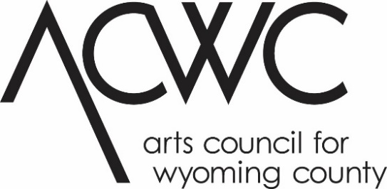

Arts Education Grant Application 2024
This project is made possible with funds from the Statewide Community Regrants Program, a regrant program of the New York State Council on the Arts with the support of the Office of the Governor and the New York State Legislature and administered by the Arts Council for Wyoming County.
Application
Eligible applicants are individual artists, groups or collectives, and unincorporated entities who are working with an eligible partner school or eligible community-based partner. Lead applicants must be 18 years of age at the time of submission and may not be enrolled in a full-time undergraduate degree program. The artist or their sponsor agency must have been living or permanently based in Allegany or Wyoming County for at least 6 months and will complete their project in Allegany or Wyoming County, respectively, in the 2024 calendar year. Please consult the Art Education Guidelines for more eligibility requirements. For further information, contact the ACWC Grants Coordinator, at (585) 237-3517 ext 102 or at grants@artswyco.org

Application Deadline: Friday, January 19, 2024.
Application must be received at ACWC’s office by 4 PM.

Deadline for Review of applications, December 1, 2023 by 4pm.

Application Checklist:
- FOR NEW APPLICANTS: Attend an application seminar or set up an appointment for a meeting with the ACWC Grant Coordinator. Past applicants please contact the Grants Coordinator notifying them of your intent to apply.
- Complete the application form, narrative and timeline. Be sure to sign (get sponsor signatures if applicable)
- Collect Support materials:
  - Artist’s updated resume/CV and updated artist statement or other descriptive text of creative work for artist(s) involved in project.
  - Samples of artist’s previous work that supports your proposed project (5-10 images on CD or DVD, labeled, with separate title sheet; 7-10 pages of manuscripts; 5-10 creative writing samples; OR 3-5 minute presentations on CD or DVD); other as relevant. Include a stamped, self-addressed envelope for return of work if applicable.
  - Links to websites, videos, etc. are acceptable as long as they pertain to the project.
  - For Pre-K-12 In-School or After-School Projects (A): Letter of commitment from the partner school to organization or artist. Refer to guidelines.
  - For Community Based Learning (B): Letter of Commitment which details the partner’s support of the project and anticipated roles and responsibilities for each partner involved. Refer to guidelines.
  - For applications submitted by a Fiscal Sponsor: Letter of Agreement with the sponsored group/artist that clearly outlines the administration of the grant and defines mutual responsibilities.
  - Letter of endorsement or cooperation from proposed site and/or community involved in project.
- For applicant artists or lead applicant of artist group, proof of CURRENT residency with ONE of the following (NOTE: all documents must contain the individual’s name and address and must be dated no earlier than two years prior to an application):
  - Telephone Bill
  - Utility bill
  - Credit card statement (first page only; social security and financial information should be blocked)
  - Current lease or mortgage agreement listing the artist’s name and Wyoming County address
  - NYS Driver’s License or ID card
  - Voter registration card

Other requirements from applicant organization (if applicable):
- Financial statement of the last completed fiscal year
- List of board members’ names and addresses
- Organization’s proof of not-for-profit status.

Submit your application and the accompanying materials to:

ACWC Grants Coordinator
Arts Council for Wyoming County
31 South Main Street
PO Box 249
Perry, NY 14530

Or email grants@artswyco.org*

*If sending large files, contact Grants Coordinator for further instructions.

When typing into form, delete and replace blank lines with text. Please refer to this program’s guidelines for specific, detailed instructions.

APPLICATION
Application for:

___ A. Pre-K-12 In-School or After-School Projects: Eligible Applicants include Individual artists, groups or collectives, and unincorporated entities who are working with an eligible partner school.
___ B. Community Based Learning: Eligible include nonprofit organizations; individual artists, groups or collectives; or unincorporated entities who are working with an eligible fiscal sponsor or community partner approved by ACWC.

Project Title: ___________________________________________________________________

Art Form/Media: ________________________________________________________________

Applicant (check one):

___ Artist ___ Non-Profit Organization ___ Sponsored Artist ___ Sponsored Group

Name of Applicant: ______________________________________________________________

Sponsoring Organization (if applicable): _____________________________________________

Applicant Address: ______________________________________________________________

City: __________________________________________ State: _________ Zip: _____________

Applicant Email: __________________________________________ Phone: ________________

NYS Assembly District: _______NYS Senate District: _______ US Congressional District: _______

For A. Pre-K-12 In-School or After-School Projects:

School: ______________________________________________________Grades: ___________

School Address: ________________________________________________________________

City: __________________________________________ State: _________ Zip: _____________

Teacher Partner: ________________________________________________________________

Teacher Partner Email: ___________________________________________________________

Teacher Partner Phone: __________________________________________________________

Dates and times project will take place: _____________________________________________

Number of contact days (minimum 3): __________ Number of students served: ____________

For B. Community Based Learning:

Describe the group to be served by this project:

___ Senior Citizens ___ Youth Group (such as Cub Scouts, etc.) ___ Other (describe)

_____________________________________________________________________________

If not the applicant, who is the artist(s) for this project?

Artist Name ____________________________________________________________________

Artist Address __________________________________________________________________

City____________ _____________________________________State _____ Zip ____________

For Fiscal or Community-Based Partner Sponsorship:

Organization Fiscal Year Runs: _____/_____ to _____/_____

Year Organization was formed/incorporated: _______________

Proof of Not-For-Profit Status: Please check one that applies and submit a copy of the document proving non-profit status with this application.
US Internal Revenue Service 501(c)(3)
NYS Charities Registration (Article 7A)
Unit of Local Government
NYS Not-For-Profit Corporation (Charter from Board of Regents S.216)
Certificate of Incorporation under S.402 of the NYS Not-For-Profit Law
Narrative:
Your proposal will be evaluated on the basis of this narrative, so be as thorough as possible, and be sure to include the goals and evaluation criteria for the project. Answer the questions in the order presented and number your corresponding responses. If you must submit your application in a hard copy format, your narrative should be no more than two single sided pages in size 12 font.
- Give a concise description of the project for which funds are being requested.
- Describe the group to be served by this project. Who are the learners?
- How many people will be directly and actively involved with carrying out the project or event? What are their roles?
- Create a work plan for the project including the roles of teacher(s), students and teaching artist(s), and anyone else involved in the project. Please include the goal or goals of the activity and how success will be evaluated, and dates of expected completion milestones.
- Attach a rubric and project evaluation process.
- REPEAT PROJECTS ONLY: Describe any changes you will make in your project this year, and the ways these changes will improve the project.

Timeline:
Include a timeline of completion milestones throughout the proposed project (for example: all interviews will be completed by May 31, 2021; all photos will be printed by October 15; 5 of 15 poems will be completed by April 10). This timeline should be reviewed with a representative of your sponsoring agency, if applicable. The timeline should be signed by both you and the sponsor representative.

Budget:
Please submit a budget for your project that includes all expenses and income. Be sure to include in-kind donations of time and materials. To complete this portion of the application, you may use the budget form provided or your own form. Note: An Excel spreadsheet is available for your use. Please contact the ACWC Grants Coordinator at grants@artswyco.org or visit the Grants page at www.artswyco.org to download this form.

A sample budget form is included on the following page.

Please refer to the Budget section of the Arts Education Guidelines for detailed instructions concerning eligible/ineligible expenses and amount limits, etc.

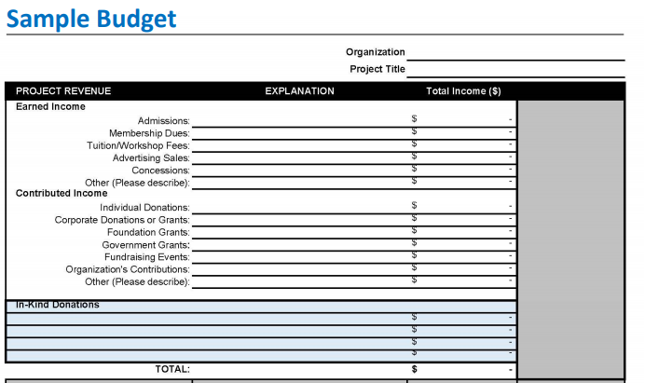
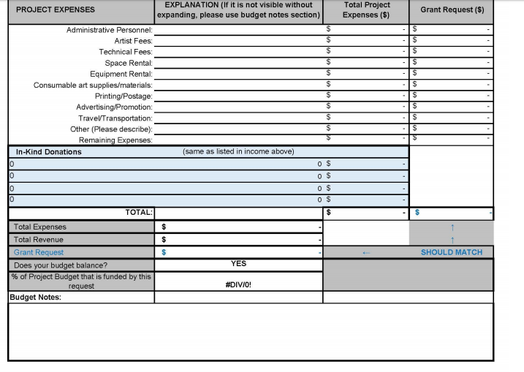

Applicant’s Signature and Date:
I certify that all statements made in this application are true to the best of my knowledge. I have read the guidelines of the ACWC Arts Education Grant Program and certify that this application complies with and is made subject to said guidelines. I certify that I reside in Allegany or Wyoming County and have done so for at least six months prior to the application deadline. I certify that I am at least 18 years of age, and that I am not enrolled as a full-time undergraduate student. I acknowledge that the Arts Council for Wyoming County is not liable for damage or loss of materials submitted.

Name (print): __________________________________________________________________

Signature: _____________________________________________________________________

Date: _________________________________________________________________________

Sponsoring Agency Representative, if applicable (person legally eligible to obligate the not-for-profit organization)

Name (print): __________________________________________________________________

Signature: _____________________________________________________________________

Date: __________________________________________________

