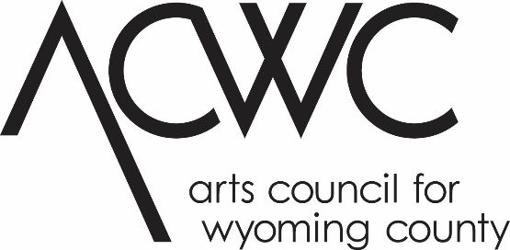

Individual Artist Grant Application 2024
This project is made possible with funds from the Statewide Community Regrants Program, a regrant program of the New York State Council on the Arts with the support of the Office of the Governor and the New York State Legislature and administered by the Arts Council for Wyoming County.
Application
Eligible applicants are individual artists who live in Allegany or Wyoming County, are at least 18 years of age, and will complete their project in Allegany or Wyoming County, respectively, in the 2023 calendar year. Undergraduate students that are enrolled full-time in classes may not apply. Please consult the Individual Artist Guidelines for more eligibility requirements. For further information, contact the ACWC Grants Coordinator at (585) 237-3517 ext 102 or at grants@artswyco.org

Application Deadline: Friday, January 19, 2024. Application must be received at ACWC’s office by 4 PM.
Deadline for Review of applications, December 1, 2023 by 4pm.
When typing into form, delete and replace blank lines with text. Please refer to this program’s guidelines for specific, detailed instructions.

Artist: ________________________________________________________________________
Legal Mailing Address: ___________________________________________________________
City:______________________________ State:_____________________ Zip:______________
Phone:________________________________ Email:___________________________________
NYS Assembly District #: ______ NYS Senate District #:_____ US Congressional District #:______

Application Checklist:
- FOR NEW APPLICANTS: Attend an application seminar or set up an appointment for a meeting with the ACWC Grant Coordinator. Past applicants please contact the Grants Coordinator notifying them of your intent to apply.
- Complete the application form, narrative and timeline. Be sure to sign.
- Collect Support materials:
  - Updated resume/CV
  - Updated artist statement
  - Samples of previous work that supports your proposed project (5-10 images – photos or images on CD or DVD, labeled, with separate title sheet; 7-10 pages of manuscripts; 5-10 examples or pages of poems; OR 3-5 minute presentations on CD or DVD). Links to websites, videos, etc. are acceptable as long as they pertain to your project.
  - Letters of support from artists and/or community partners describing their role in the project
  - Letter of endorsement or cooperation from proposed site and/or community involved in project
- Show proof of CURRENT residency with ONE of the following (NOTE: all documents must contain the individual’s name and address and documentation must be dated no earlier than two years prior to an application).
- Telephone bill
- Utility bill
- Credit card or bank statement (first page only; social security and financial information should be blocked)
- Current lease or mortgage agreement listing the artist’s name and NYS County address
- NY State Driver’s License or ID card
- Voter Registration Card
- Include a stamped, self-addressed envelope for return of work if applicable
- Submit your application and the accompanying materials to:

ACWC Grants Coordinator
Arts Council for Wyoming County
31 South Main Street
PO Box 249
Perry, NY 14530
Or email to grants@artswyco.org

*If sending large files, contact Grants Coordinator for further instructions.
Narrative:
Please answer the following questions sequentially, numbering the corresponding responses. If you must submit your application in hard copy format, your narrative should be no more than two single sided pages in size 12 font.
- Describe the artistic work you intend to produce in this project. In what ways will this work contribute to your growth as an artist? How does it fit in with the trajectory of your work?
- Describe the community Engagement portion of your project: how will the community be included? In what way does the work of art you will create represent the community? OR, how it will impact the community in which it will be presented?
- What is the budget for this project? All funds may be allocated as you see fit but must be listed in this budget. Describe any other funding source if the project will cost more than $2,500, including donated time and supplies.

Timeline:
Include a timeline of completion milestones throughout the proposed project (for example: all interviews will be completed by May 31, 2023; all photos will be printed by October 15; 5 of 15 poems will be completed by April 10).

Budget:
Please submit a budget for your project that includes all expenses and income. Be sure to include in-kind donations of time and materials. To complete this portion of the application, you may use the budget form provided or your own form. Note: An Excel spreadsheet is available for your use. Please contact the ACWC Grants Coordinator at grants@artswyco.org or visit the Grants page at www.artswyco.org to download this form.

A sample budget form is included on the following page.
Please refer to the Budget section of the Individual Artist Guidelines for detailed instructions concerning eligible/ineligible expenses and amount limits, etc.
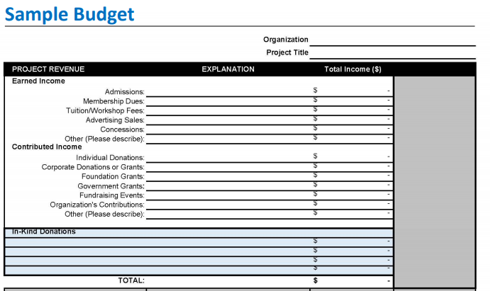
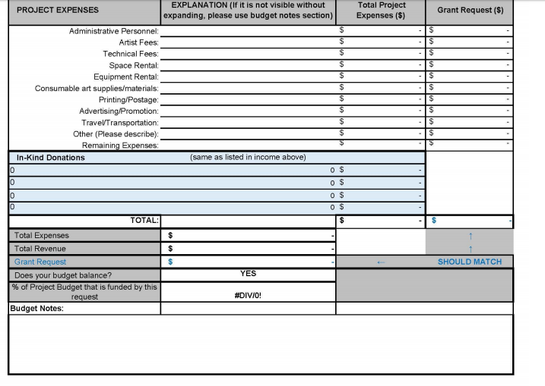

Applicant’s Signature and Date:

I certify that all statements made in this application are true to the best of my knowledge. I have read the guidelines of the ACWC Arts Grant Program and certify that this application complies with and is made subject to said guidelines. I certify that I reside in Allegany or Wyoming County and have done so for at least six months prior to the application deadline. I certify that I am at least 18 years of age, and that I am not enrolled as a full-time undergraduate student. I acknowledge that the Arts Council for Wyoming County is not liable for damage or loss of materials submitted.

Name (print): __________________________________________________________________

Signature: _____________________________________________________________________

Date: _________________________________________________________________________

