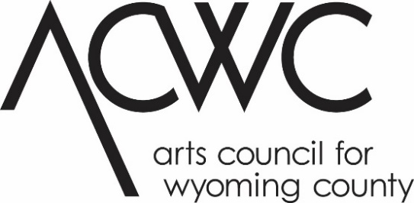

Community Arts Grant Application 2024
This project is made possible with funds from the Statewide Community Regrants Program, a regrant program of NYSCA with the support of the Office of the Governor and the New York State Legislature and administered by the Arts Council for Wyoming County.

Community Arts grants provide support to community-based organizations, groups, collectives or artists for arts and cultural projects. This program enables emerging artists and organizations to grow professionally and to enhance the cultural climate in communities and neighborhoods where they live and work. Community Arts grants can fund but are not limited to: exhibitions, performances, concerts (all disciplines), festivals, demonstrations and workshops, screenings or readings.
This is a competitive process. All applications are extensively evaluated according to the criteria and priorities. Through Community Arts grants, the Arts Council for Wyoming County, NYSCA and the NYS Legislature hope to expand, enhance and increase arts and cultural programs in our community.

APPLICATION DEADLINE JANUARY 19, 2024 AT 4 PM.

Deadline for Review of applications, December 1, 2023 by 4pm.
2024 Final Reports are due no later than 30 days after the completion of the project. All reports must be submitted by January 29, 2025.

Application
To be eligible to apply for a Community Arts grant or to be a sponsor for an artist or artist group, organizations must be based in Allegany or Wyoming County and have one of the following with proof of the same:
- A 501(c)(3) or New York State non-profit organization with an active board of trustees either incorporated in NYS or registered to do business in NYS
- A government or quasi-government entity, or Tribal Nation, OR
- With approval from ACWC, individual artists, groups or collectives, and unincorporated entities who are working with an eligible fiscal sponsor or community-based partner are eligible.
  - Lead applicants must be 18 years of age at the time of submission and may not be enrolled in a full-time undergraduate degree program
  - Project sponsors and partners must be based in Allegany or Wyoming County
Please note:
- Fiscal sponsors must meet the same basic eligibility requirements as the applicant organization and provide the same required documents
- Community-based non-profit partners are only required to provide a letter of commitment confirming the partnership with the applicant and outlining the scope of the partnership and each partner’s investment or contribution (in-kind and/or cash) toward the proposed project.
Please consult the Community Arts Grant Guidelines for more eligibility requirements. For further information, contact the ACWC Grants Coordinator, at (585) 237-3517 ext 102 or at grants@artswyco.org .

Application Checklist:
- FOR NEW APPLICANTS: Attend an application seminar or set up an appointment for a meeting with the ACWC Grant Coordinator. Past applicants please contact the Grants Coordinator notifying them of your intent to apply.
- Complete the application form, narrative and timeline. Be sure to sign (get sponsor signatures if applicable)
- Collect Support materials:
  - Updated resume(s)/CV(s) and artist(s) statement or other descriptive text of creative work for artist(s) involved in project.
  - Samples of previous work that supports the proposed project (5-10 images on CD or DVD, labeled, with separate title sheet; 7-10 pages of manuscripts; 5-10 creative writing samples; OR 3-5 minute presentations on CD or DVD); other as relevant. Links to websites, videos, etc. are acceptable as long as they pertain to your project. Include a stamped, self-addressed envelope for return of work if applicable.
  - Letters of support from artists and/or community partners describing their role in the project.
  - Letter of endorsement or cooperation from proposed site and/or community involved in project.
  - For applications submitted by a Fiscal Sponsor: Letter of Agreement with the sponsored group/artist that clearly outlines the administration of the grant and defines mutual responsibilities.
  - Proof of not-profit status. Refer to guidelines for acceptable proof.
  - Your organization’s Board of Directors roster (names and addresses).
  - Organizational financial information: audit, accountant prepared statements, or internal statements signed by board treasurer.
- Submit your application and the accompanying materials to by the deadline to:

ACWC Grants Coordinator
Arts Council for Wyoming County
31 South Main Street
PO Box 249
Perry, NY 14530

Or email grants@artwyco.org*

*If sending large files, contact Grants Coordinator for further instructions.

When typing into form, delete and replace blank lines with text. Please refer to this program’s guidelines for specific, detailed instructions.

APPLICATION

Project Title: ___________________________________________________________________

Legal Name of Organization: ______________________________________________________

County: ________Wyoming ________Allegany

Employee Identification Number (EIN): ______________________________________________

Legal Mailing Address: ___________________________________________________________

City: __________________________________________ State: _________ Zip: ____________

Contact Person #1: ______________________________________________________________

#1 Email: _______________________________________ #1 Phone: ______________________

Contact Person #2: ______________________________________________________________

#2 Email: _______________________________________ #2 Phone: ______________________

Fiscal Sponsor: _________________________________________________________________

Community-Based Partner: _______________________________________________________

How many individual events will take place as part of this project? _______________________

How many artists will participate in the project: ______________________________________

Dates and times project will take place: _____________________________________________

Target Audience: _______________________________________________________________

Anticipated number of community members served TOTAL (add together the estimated attendance for each event): ______________________________________________________

Per Category: Children: _____ Teens: _____ Adults: _____ Seniors: _____ Special Needs: _____

What accommodations are in place for people with disabilities? __________________________

______________________________________________________________________________

NYS Assembly District: _______NYS Senate District: _______ US Congressional District: _______

Has your organization ever applied to NYSCA? _________ What year: _____________________

Organization Fiscal Year Runs: _____/_____ to _____/_____

Year Organization was formed/incorporated: _______________

Proof of Not-For-Profit Status: Please check one that applies and submit a copy of the document with this application.

US Internal Revenue Service 501(c)(3)
NYS Charities Registration (Article 7A)
Unit of Local Government
NYS Not-For-Profit Corporation (Charter from Board of Regents S.216)
Certificate of Incorporation under S.402 of the NYS Not-For-Profit Law
Please share your mission statement or briefly describe the purpose and activities of your organization:

______________________________________________________________________________

______________________________________________________________________________

______________________________________________________________________________

______________________________________________________________________________

______________________________________________________________________________

Narrative:
Your proposal will be evaluated on the basis of this narrative, so be as thorough as possible, and be sure to include the goals and evaluation criteria for the project. Answer the questions in the order presented and number your corresponding responses. If you must submit your application in a hard copy format, your narrative should be no more than two single sided pages in size 12 font.

- Give a concise description of the project for which funds are being requested. If you are applying to additional funding sources, please let us know what specifically you would like the Community Arts grant to fund.
- What are your goals for this project? What are the particular benefits to audience members, participants, the community and your organization?
- How many people will be directly and actively involved in carrying out the project or event? What are their roles?
- Why did your organization choose to carry out its project in this way (for example: choice of artist(s)/art form(s), location, time of year, time of day, etc.).
- How do you plan to advertise, promote and market your project (for example: advertising, press releases, website, flyers, email, outreach, etc. Please list publications)
- How will you measure success?
- REPEAT PROJECTS ONLY: Describe any changes you will make in your project this year, and the ways these changes will improve the project.

Timeline:
Include a timeline of completion milestones throughout the proposed project (for example: all interviews will be completed by May 31, 2021; all photos will be printed by October 15; 5 of 15 poems will be completed by April 10).

Budget:
Please submit a budget for your project that includes all expenses and income. Be sure to include in-kind donations of time and materials. To complete this portion of the application, you may use the budget form provided or your own form. Note: An Excel spreadsheet is available for your use. Please contact the ACWC Grants Coordinator at grants@artswyco.org or visit the Grants page at www.artswyco.org to download this form. A sample budget form is included on the following page.
Please refer to the Budget section of the Community Arts Grants Guidelines for detailed instructions concerning eligible/ineligible expenses and amount limits, etc.
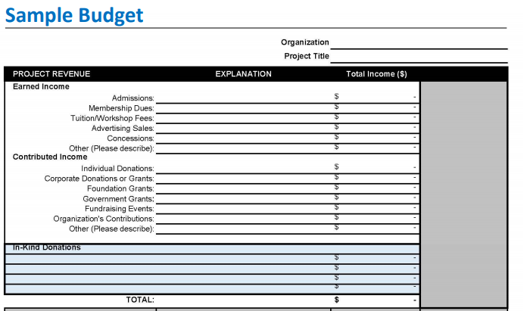
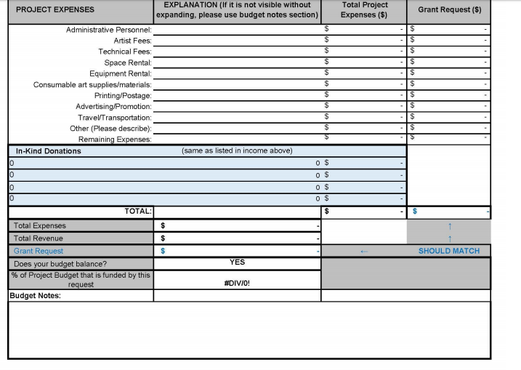

Applicant’s Signature and Date:
I certify that all statements made in this application are true to the best of my knowledge. I have read the guidelines of the ACWC Community Arts Grant Program and certify that this application complies with and is made subject to said guidelines. I certify that I reside in Allegany or Wyoming County and have done so for at least six months prior to the application deadline. I certify that I am at least 18 years of age, and that I am not enrolled as a full-time undergraduate student. I acknowledge that the Arts Council for Wyoming County is not liable for damage or loss of materials submitted.

Name (print): __________________________________________________________________

Signature: _____________________________________________________________________

Date: _________________________________________________________________________

Sponsoring Agency Representative, if applicable (person legally eligible to obligate the not-for-profit organization)

Name (print): __________________________________________________________________

Signature: _____________________________________________________________________

Date: __________________________________________________

